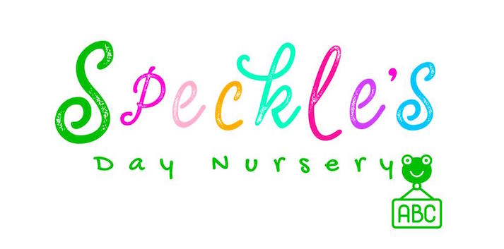

Speckles Day Nursery Fees 2024

Monthly Fees – Full Days 8.00am - 6.00pm. Early drop off 7.30am: £6.00

The nursery is open for 51 weeks per year. Bank holidays, closures and inset days are accounted for within our fee structure and are fully payable.

 | 0-3 Years | 2-5 Years  15/11 hours funded | 3-5 Years 30/22 hours funded
5 Days | £1430.00 | £1100.00 | £825.00
4 Days | £1145.00 | £825.00 | £550.00
3 Days | £855.00 | £550.00 | £275.00
2 Days | £575.00 | £275.00 | N/A

Funding

- Funding – Funding is offered as a stretched entitlement; 15 hours universal entitlement is given as 11 hours over 51 weeks per year.
- 30 hours extended entitlement is given as 22 hours over 51 weeks per year.
- (minimum attendance is 2.5 days per week- 25 hours)
- You will need to provide us with an eligibility code for 2 years and 30-hour funding entitlement.
- Children who claim funded hours will be charged £4.00 per am session, £3 per pm session or £6.00 per full day for consumables, which includes meals and snacks. This charge is applicable on funded days. This charge is always payable including if your child does not attend Nursery.

Additional Information

- Meals/snacks are included in the cost of your nursery place for full fee-paying parents.
- Nappies and fragrance-free wipes are included.
- Additional days will be £75 for all age groups.
- AM or PM sessions will be £40 per session (8am-1pm) (1pm -6pm)
- Am or Pm sessions are a minimum of 4 sessions.
- Additional hours will be £8.50 per hour for all age groups.

Terms and Conditions (Nursery contract)

- Speckles Day Nursery is open from 8am – 18:00pm Monday to Friday 51 weeks per year except for recognised bank holidays. An early start at 07:30am is available for an additional cost- please note that our fees consider the Nursery closures and bank holidays over the Christmas period, meaning that no reduction is given for our Christmas closure, or bank holidays.
- Attendance fees are detailed on the price list and are payable one month in advance.
- To secure a place for your child a deposit of £100 and a £50 non-refundable registration fee is required; the deposit will be deducted from your last invoice. In the event a nursery place is not taken the £100 deposit is non-refundable. Children must attend for at least 6 months before the deposit can be refunded.
- A Nursery place cannot commence until we hold a contract signed by a parent. We also need to see your child’s Birth Certificate.
- No reduction in fees can be offered in the event of absence through illness, or holidays.
- No reduction in fees can be offered for Bank Holidays, adverse weather conditions, or other reasons, such as unavoidable nursery closure.
- Late fees will apply if a child is not collected on time – these are detailed on our fee structure.
- Fees are payable by the 1st of every month. If you do not make payment your child’s Nursery place will be at risk. Any payment late will result a late charge of £25 and withdrawal of your child’s Nursery place. If you are unable to make payment, please speak to the Nursery Manager as soon as possible.
- Late fees apply once a parent is 5 minutes late to collect this is £5.00 for the first 5 minutes and £1 per minute after, a digital clock will be used to determine your actual time of arrival. If you arrive after 6.30pm late fees go up to £2 per minute for the whole duration of your lateness.
- One month’s written notice is required if you wish to terminate your child’s place at Speckles Day Nursery or if you wish to change their hours/days of attendance.
- Medicines can only be administered on completion of a Nursery Medicine form. We only administer prescribed medicines.
- We are unable to accept any child with an infectious illness.
- Parents are required to inform the Nursery of any absence on the day of absence or in advance.
- We do not offer ‘swap’ days if a child does not attend on their allocated day.
- We close for 2 INSET days a year for staff training – these days are accounted for within our fee structure, meaning they are payable. Parents will be given notice of Inset days 6 weeks in advance.
- Any child with diarrhoea/sickness must have 48 hours clear form diarrhoea/sickness before returning to the Nursery.
- The 48-hour rule also applies to children who have been prescribed antibiotics.
- If the Nursery feels a child is unwell every effort will be made to contact the parents/carers and the nursery will request that the child is collected.
- Speckles Day Nursery does not accept responsibility for loss or damage of personal items.
- When you sign the Nursery registration form you are agreeing to the terms and conditions of the Nursery.
- We reserve the right to change our terms and conditions, fees and attendance patterns with 4 weeks’ notice.

Childs Name……………..

Start date…………………..

Signed Manager……………………….

Signed parent…………………………..

Date

